CCNP Period 6-7

3/11/19

VOIP part 2 with PSTN

Jeffrey Xu

Fix your boxes.

**Purpose:**

VOIP is essential for companies large and small who want to set up a local and or external calling network. This lab let us get use to setting up VOIP (Voice Over IP) with PSTN (Public Switched Telephone Network) and adding on new features to Cisco VOIP phones such as Voicemail, Custom ringtone, and Music on hold.

**Background:**

For this lab, we needed to take what we had learned about VOIP part one and simply add new features to it. I had to utilize 2 VMs (Virtual Machines) to complete this lab, I used CUCM (Cisco Unified Communications Manager) to set up music on hold, custom ringtone, and external dial out and in. While we needed the addition of CUC (Cisco Unity Communications) for the addition of voicemail. Setting up CUC was a bit picky with all of the specifications needed to setup the machine. But starting from the top, Music on hold used TFTP (Trivial File Transfer Protocol) to send set music files in the WAV format which I used an online converter to grab and then used a video/music editor to cut the time. Custom ringtone was the same but you needed to grab the Ringtone.xml file and edit it to your own preferences to have it show up in your phones. To be honest, the essential parts of this lab were only voicemail and dial in and out. Everything else you do to the phones can be just considered extra vanity. But of course there are a few other protocols that are useful, such as using SMTP (Simple Mail Transfer Protocol) to transfer voicemail files to an email address or adding all kinds of other protocols.

**Lab Set-up:**

For this lab, I used 1 2811 router with the FX0 ports extension that supported Voice-ports and other VOIP commands, no other routers will work for this lab. I also used 2 VMs with different IP addresses on the same network scheme to allow my phones to connect to CUCM and CUC. And last I used 1 Catalyst 3560 POE switch to allow phones to receive power and routing to the servers and router. Not included in the topology is the PSTN box connected to our routers FX0 3/0/1 port that allows us to receive a phone number and dial in and out.

**TOPOLOGY:**

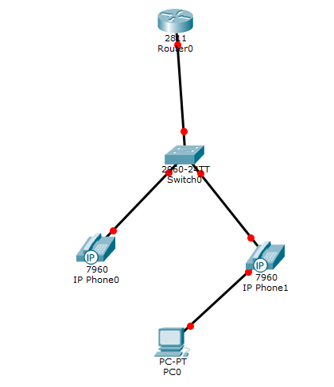

**Router 1 Configurations:**

hostname R1

no aaa new-model

resource policy

memory-size iomem 10

no network-clock-participate slot 1

ip subnet-zero

ip cef

no ip dhcp use vrf connected

ip dhcp pool Voice

network 172.16.0.0 255.255.255.0

default-router 172.16.0.1

option 150 ip 172.16.0.2

ip dhcp pool Data

network 172.16.0.16 255.255.255.240

default-router 172.16.0.17

option 150 ip 172.16.0.2

voice call send-alert

voice rtp send-recv

voice service voip

h323

interface FastEthernet0/1.1

encapsulation dot1Q 10

ip address 172.16.0.1 255.255.255.240

no snmp trap link-status

interface FastEthernet0/1.2

encapsulation dot1Q 20

ip address 172.16.0.17 255.255.255.240

no snmp trap link-status

voice-port 0/3/1

signal groundStart

timing hookflash-out 50

timing guard-out 1000

connection plar opx 1111

caller-id enable

ccm-manager config server 172.16.0.20

ccm-manager config

mgcp call-agent 172.16.0.20 service-type mgcp version 0.1

mgcp profile default

dial-peer voice 10 voip

destination-pattern 1111

session target ipv4:172.16.0.20

dtmf-relay h245-signal h245-alphanumeric

dial-peer voice 1 pots

destination-pattern 9T

direct-inward-dial

port 0/3/1

forward-digits 11

telephony-service

max-ephones 2

max-dn 2

ip source-address 172.16.0.20 port 2001

create cnf-files version-stamp 7960 Jan 22 2015 23:53:36

max-conferences 8 gain -6

transfer-system full-consult

scheduler allocate 20000 1000

ntp master

**Switch 1 Configurations:**

en

config t

hostname S1

vlan 10

name Voice

vlan 20

name Data

int range fa0/3 - 4

switchport mode access

switchport voice vlan 10

switchport mode access

switchport access vlan 20

int fa0/20

switchport trunk encapsulation dot1q

switchport mode trunk

**Screen shots for configurations:**

Music on Hold (MOH):

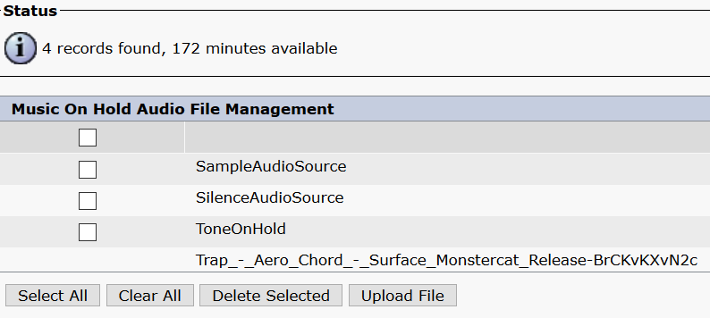

Use the “Upload files” button and select the music file you want to use.

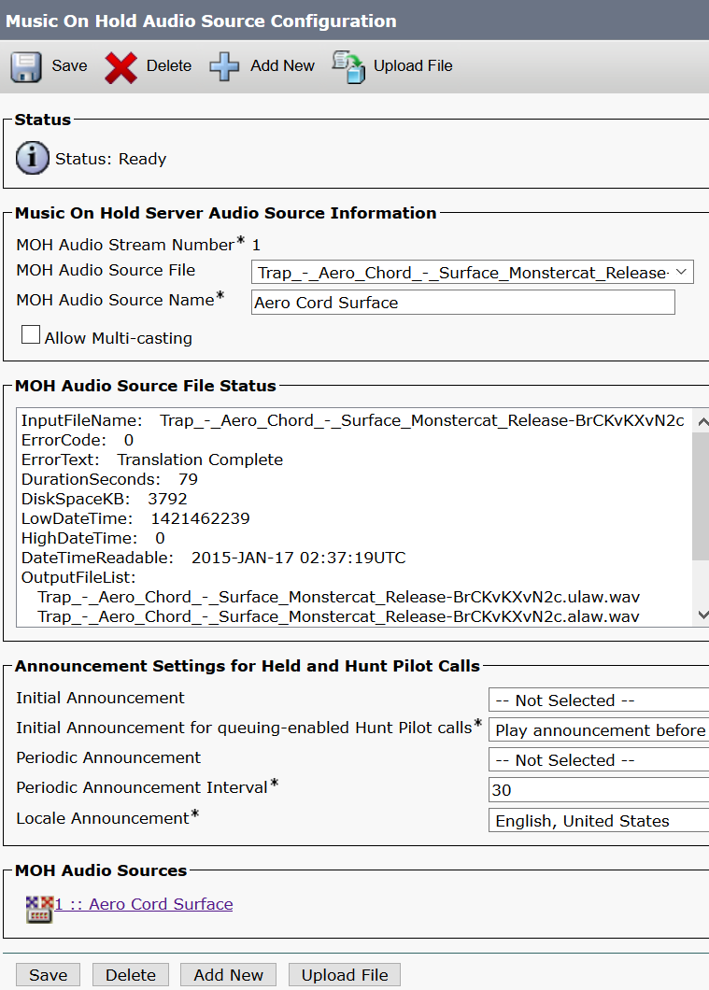

Set up this Audio Source Configuration to make a profile to select when updating phones with the music. You can ether go to bulk administration to update the phones or going to the phones themselves. Bulk administration can be glitchy at sometimes and make you reset your phones. Make sure to select your music file for both boxes with MOH on them.

Custom ringtone:

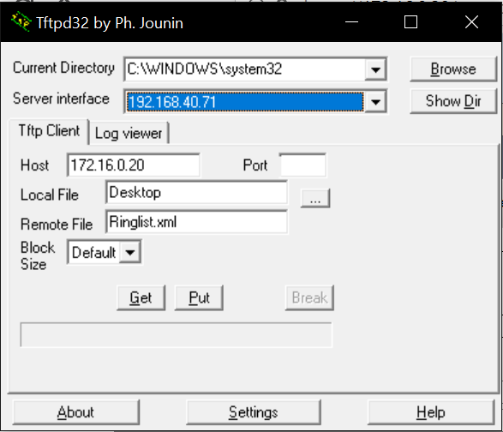

Use TFTP32 to grab the Ringlist.xml file from the VM server to edit.

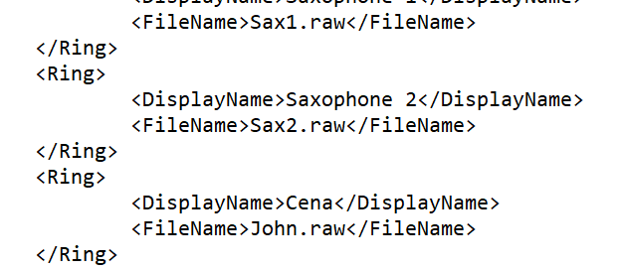

Copy the last row and edit the display name however you like but the filename must be exactly how it is named or it will not read the file.

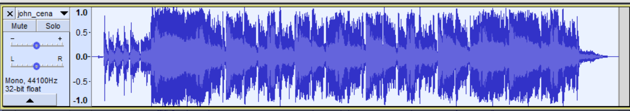

Download Audacity to edit a ringtone, right click it and change it to mono (it should split into 2, delete one of them). Change the frequency to 8000 Hz at the bottom left, and shorten the clip to 12 seconds or less (recommended below 10)

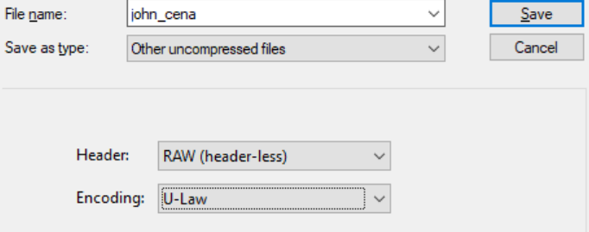

Once complete, go to the file button at the top right and click export media file. Save as an other uncompressed files, RAW header, and U-Law encoding, or else it won’t read the file in the CUCM server. Click save.

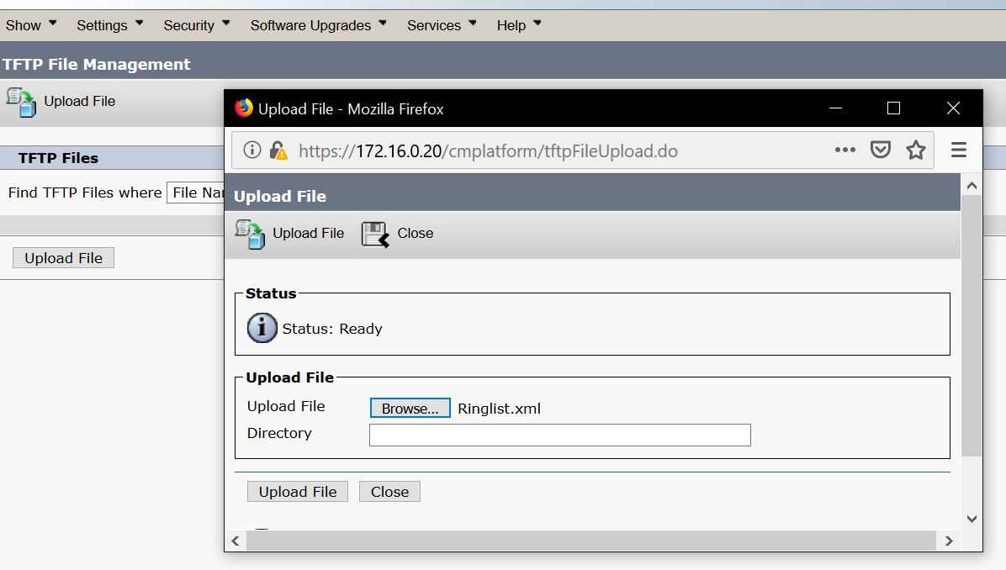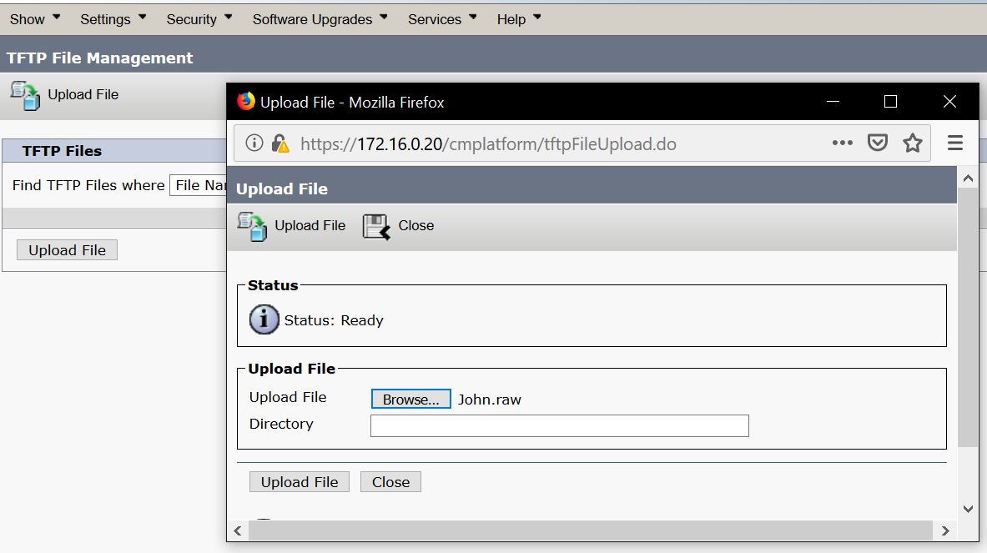

Upload both the Ringlist.xml and the music file to the TFTP file management in CUCM serviceability (in the navigation tab).

Voicemail: (By far the hardest): This is in CUC now

I NEED TO STRESS THAT INFORMATION SHOULD REPLICATE THE CUCM SIDE

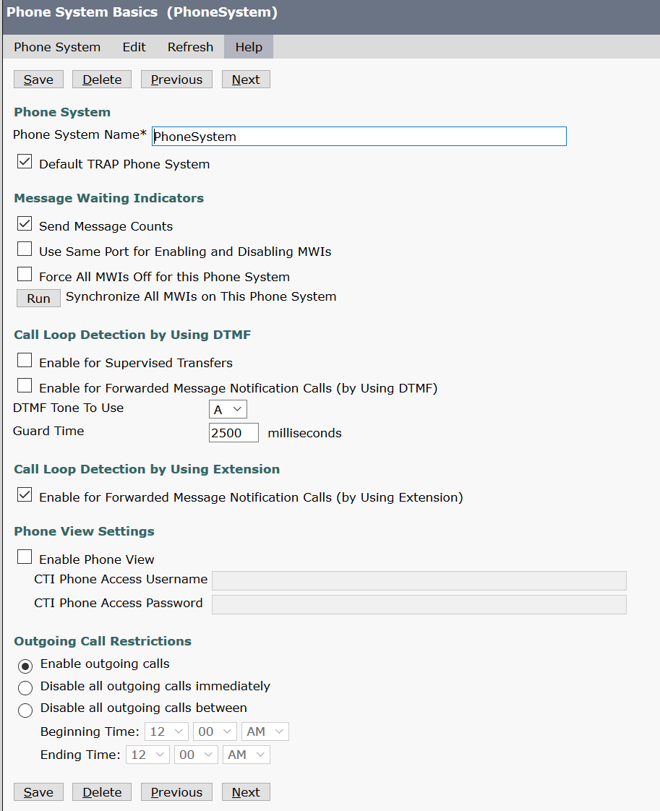

Start out with making a phone system, fill out all necessary information. There should be a wizard for this.

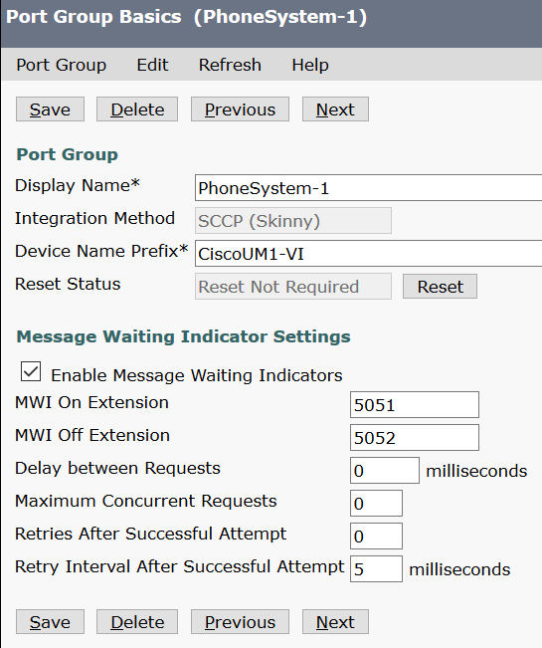

Next is port group, should be self-explanatory (MWI means message waiting indication, it lets you turn on or off the “you have voicemail indicator by dialing the number)

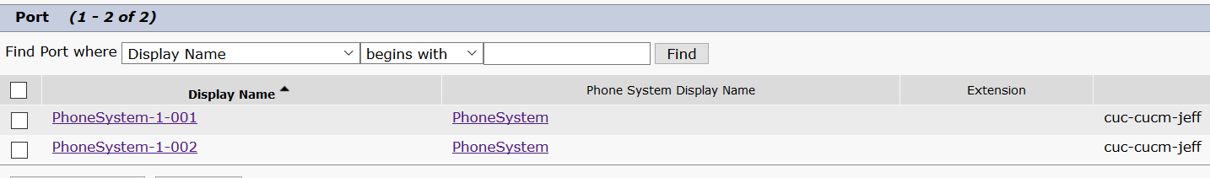

Setting up ports should also be explanatory if it’s not already made.

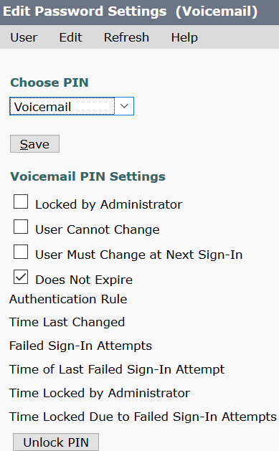

You need to make a user profile, one for each phone.

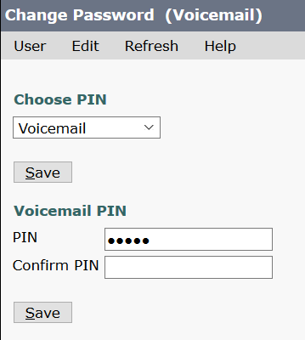

Create a PIN that you will use to access your Voicemail inbox.

CUCM side of Voicemail:

Should be a mirror copy of CUC side of Voicemail.

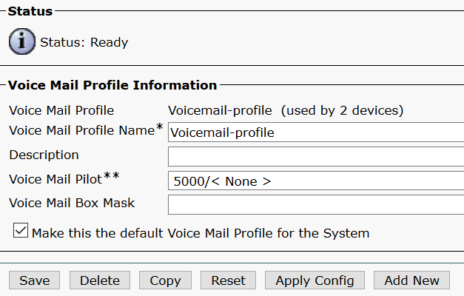

The voicemail profile should have a wizard to walk you through the configurations.



Voicemail ports should be already made when you made the voicemail profile.

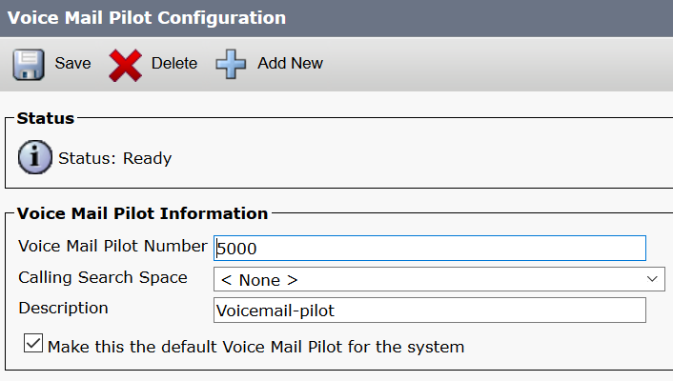

Voicemail pilot is the number the message button will be assigned to call your voicemail inbox.

When trying to dial your voicemail, you need the press the * button first, enter in your phone number, then the pin you set in your user to access your inbox.

Dial in and out: easiest of them all:

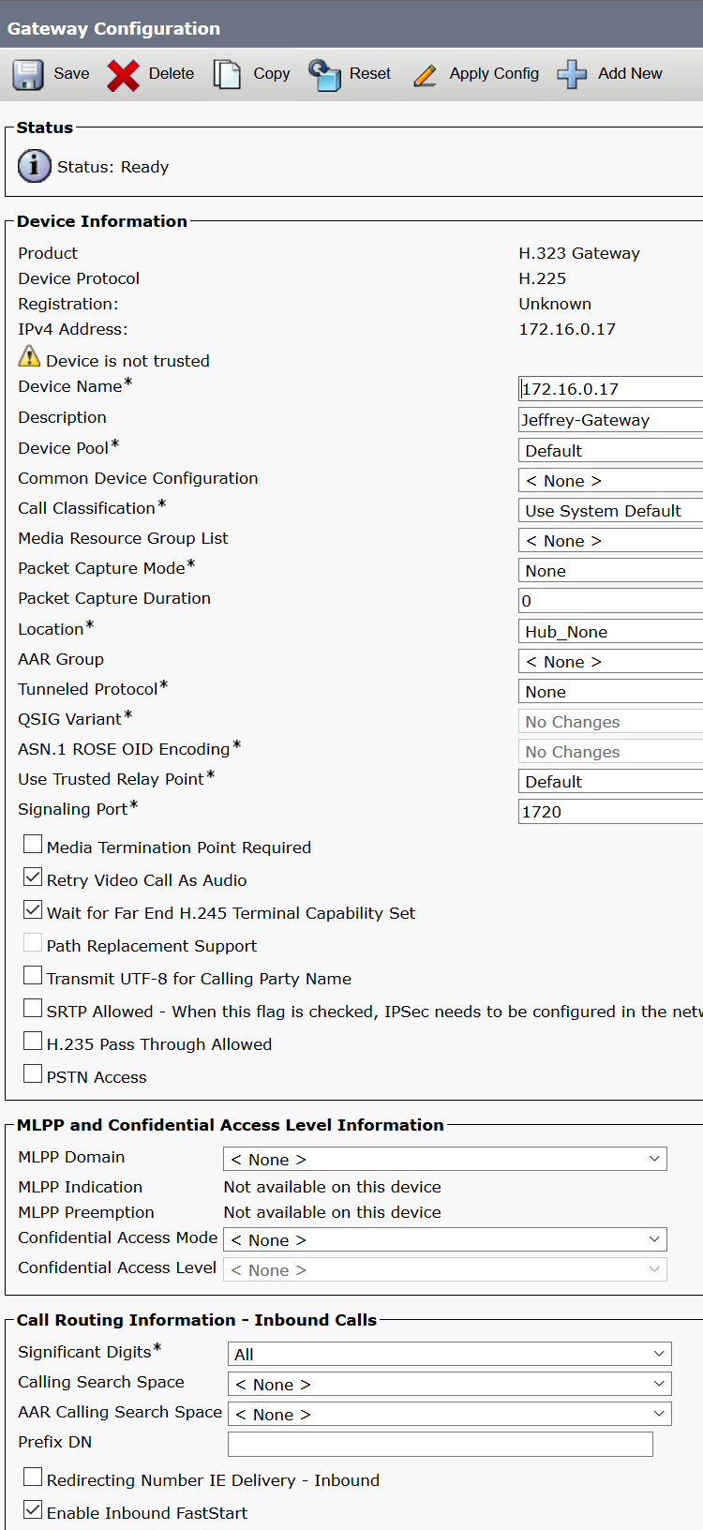

First create a h.323 gateway in the device tab. Device name should be your routers ip address

Click the enable inbound Fast start box at bottom.

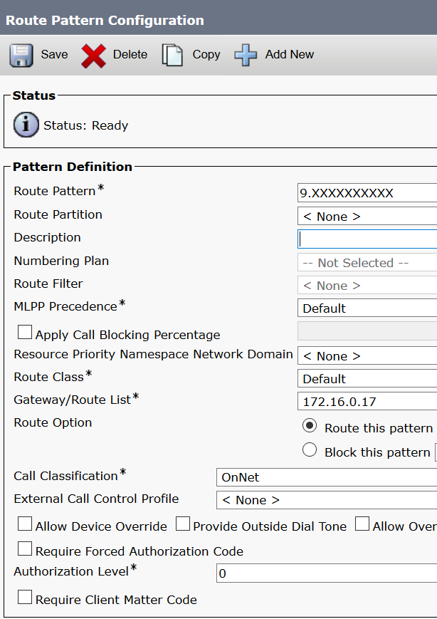

Create a route pattern in the route and hunt tab. 9 is the extension, the period means that everything behind it will be stripped off the number. And thx 10 Xs represent the normal 10 digit dial number.

Dial out router commands include:

voice-port 0/3/1----------------------------------------------The interface you want to configure

signal groundStart-------------------------------------------Type of signal we use

timing hookflash-out 50

timing guard-out 1000

connection plar opx 1111---------------------------------The phone number outside will be reaching.

caller-id enable-----------------------------------------------Shows caller-ID (Phone number)

ccm-manager config server 172.16.0.20----------------Points towards the CUCM server

ccm-manager config

mgcp call-agent 172.16.0.20 service-type mgcp version 0.1-----Same thing

mgcp profile default

dial-peer voice 10 voip----------------------------------------this allows outside to call in

destination-pattern 1111-------------------------------------Phone number that will be picking up

session target ipv4:172.16.0.20--------says, if you want to reach 1111, then go to 172.16.0.20

dtmf-relay h245-signal h245-alphanumeric-------------signal released

dial-peer voice 1 pots-------------------------------------------Allows dial out

destination-pattern 9T------------------------------------------9 is the extension, T is timeout.

direct-inward-dial

port 0/3/1---------------------------------------------------------Outgoing interface

forward-digits 11------------------------------------Number of digits dialed (11 including 9 extension)

**Problems:**

A few problems that occurred during this lab included, not knowing how to install CUC with the right hardware specifications, PSTN box not working (not my fault) Wrong ports were hot for VOIP, Wrong router used many times because they didn’t support Voice-ports with the FX0 ports, not knowing how to setup a pin number for voicemail, and many other minor issues such as not saving snapshots and needing to restart my VM because I couldn’t revert when it crashed.

**Conclusion**:

This lab gave me a headache during the dial in and out part, but not because my configurations weren’t working, but because the PSTN box wasn’t working. I feel like instead of the other protocols we should practice more useful protocols. But MOH and custom ringtone was ok. I breezed through most of this after a few hours of research at home. I can easily say that I finished this lab all by myself.